CHAPTER ONE
INTRODUCTION

1.0 Background to the Study
Commerce in Africa has always been social. Long before the internet, trade across Ghana happened through conversation, negotiation, and personal relationships built over time in open markets and community spaces. What has changed in the past decade is not the social nature of commerce, but the medium through which it takes place. Today, millions of buyers and sellers across Ghana conduct their transactions through social media and messaging platforms such as WhatsApp, Facebook, Instagram, TikTok, Telegram, and others. A trader in Kumasi can show a customer in Accra a new product through a photograph posted online, agree on a price through a direct message, and collect payment through mobile money, all without either party leaving their home. This convergence of social interaction and commercial exchange is what the academic literature describes as social commerce, and it has become one of the most economically significant phenomena in contemporary Africa.

The scale of this transformation is well documented (Leong et al., 2024)., applying longitudinal science mapping to two decades of social commerce scholarship in Internet Research, confirmed that social commerce has evolved from a niche concept rooted in social networking sites into one of the most intensively researched paradigms in Information Systems, with scholarly output accelerating sharply after 2017. In Sub-Saharan Africa specifically, (Achieng & Malatji, 2022), in their scoping review of digital transformation among small and medium enterprises in the region, found that social media platforms have become the primary and often the only channel through which micro-enterprises engage in digital commerce. The GSMA corroborated this in its 2023 industry report, finding that 60% of micro-enterprises across six major African countries, including Ghana, relied solely on social media for their e-commerce activities (Gsma, 2023). Mobile money has accelerated this further. According to the Bank of Ghana's Payment Systems Oversight Annual Report, mobile money transactions in Ghana grew by 90% in value between 2022 and 2023, reaching GHC 1.9 trillion by year-end (Bank of, 2024). These figures are not merely impressive. They represent a fundamental restructuring of how ordinary Ghanaians participate in the economy.

Yet beneath this impressive growth lies a structural vulnerability that has not been adequately addressed. To understand it, consider a scenario that plays out countless times every week across Ghana. A buyer sees a product advertised on a social media platform. She messages the seller, who responds with additional photographs and confirms availability. They agree on a price. The seller requests upfront payment via mobile money before shipping. Trusting the seller's profile and the quality of the images, the buyer transfers the funds. And then nothing arrives. The seller becomes unresponsive. The mobile money transfer, once completed, is irreversible. There is no receipt, no order reference, no formal record of the transaction, and no institutional mechanism through which the buyer can seek redress. She has lost her money and the seller has faced no consequence.
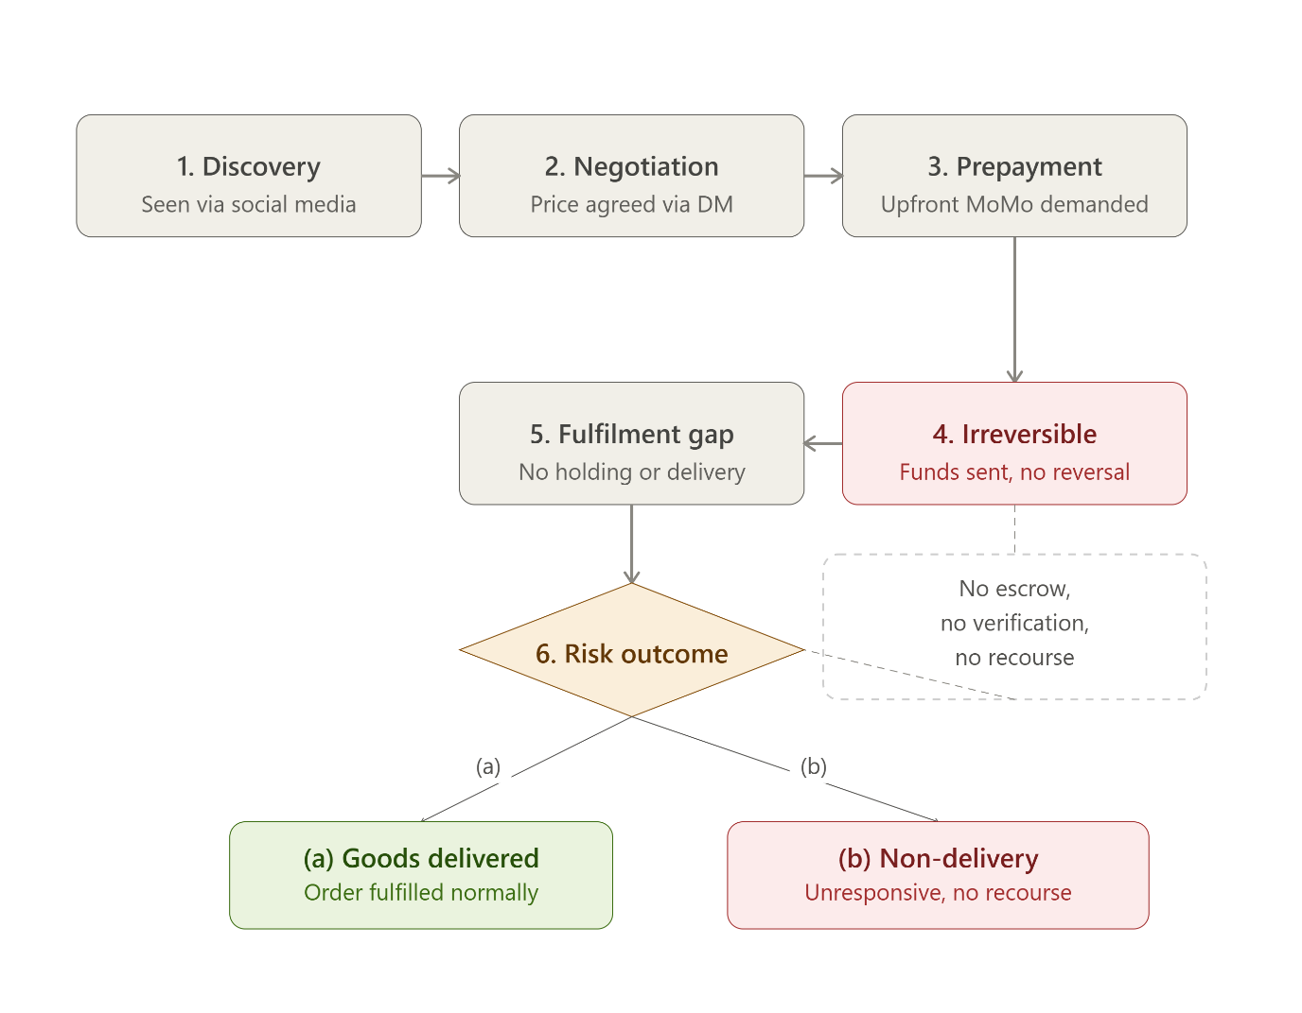

Figure 1.1: The Unprotected Social Commerce Transaction Cycle in Ghana, Showing the Point of Irreversible Risk Exposure

This is not an isolated scenario. It is a documented and growing crisis. The Bank of Ghana's 2023 Fraud Report recorded 14,655 electronic money fraud incidents in the payment service provider sector alone, representing a 20% increase from the 12,166 cases documented in 2022 (Bank of Ghana, 2023). Total financial losses across the banking and payment sectors reached approximately GHC 88 million in that year. (Arhin, 2023), analysing financial fraud indicators across Ghana's mobile payment industry, documented the rising incidence of fraud and its measurable, negative impact on the financial performance of the country's mobile payment operators. These losses fall disproportionately on informal buyers who have no formal protection layer in their transactions.

The root cause of this vulnerability is structural rather than behavioural. Informal social commerce in Ghana operates without the institutional safeguards that formal e-commerce platforms provide as standard. On a structured marketplace, buyers are protected by escrow-held payments, order tracking, return policies, and formal dispute resolution mechanisms. On a social media or messaging platform, none of these protections exist. The entire transaction depends on interpersonal trust between strangers, which is an insufficient and fragile foundation for commerce at scale.(Wang et al., 2022), in a meta-analysis of 19 studies of social commerce platforms published in SAGE Open, established that trust is a primary determinant of purchase intention in social commerce environments, with trust in sellers exerting a larger effect than other trust objects. The absence of trust does not merely reduce transactional confidence. It suppresses economic participation entirely.

Escrow mechanisms represent one of the most reliable solutions to precisely this kind of transactional risk. In an escrow arrangement, a buyer's funds are held by a trusted neutral intermediary and released to the seller only upon confirmed delivery of the agreed goods or services. If a dispute arises before delivery is confirmed, the escrow agent reviews the available evidence before disbursing any funds. This logic simultaneously protects the buyer from non-delivery risk and the seller from false non-delivery claims, while introducing a structured resolution pathway when disagreements occur. (Ali, 2022), presenting at the International Conference on Innovative Computing and Communication, demonstrated through protocol analysis that decentralised escrow mechanisms provide provably secure transaction environments for parties who do not know or trust each other, confirming the theoretical soundness of escrow as a structural trust solution.

What does not yet exist is an escrow-based transaction model designed and built specifically for informal social commerce in Ghana. As (Osabutey & Jackson, 2024), in their comprehensive review of mobile money and financial inclusion in Africa published in Technological Forecasting and Social Change, concluded, the primary policy challenge in Africa's digital payment ecosystem is not the availability of payment technology but the absence of protective mechanisms that convert payment speed into payment security. Existing formal escrow solutions are engineered for enterprise-level deployments and structured marketplaces, and are inaccessible to the trader in Tema who sells homewares through WhatsApp or the entrepreneur in Kumasi who promotes handcrafted goods on TikTok. The infrastructure to solve the problem exists. What is missing is a model that brings it within reach of the people who need it most. This study sets out to build and evaluate that model.

1.1 Statement of the Problem
The problem this study addresses is both structural and practical. At its core, it is the absence of a transaction protection mechanism within Ghana's rapidly growing informal social commerce ecosystem. This absence manifests in four specific and interconnected deficiencies, each of which compounds the others and together produce an environment in which neither buyers nor sellers can transact with genuine confidence.

The first deficiency is the absence of conditional payment control. Mobile money and digital payment tools available to informal social commerce participants in Ghana operate on an instant and irreversible transfer model. Once a buyer sends funds to a seller, those funds are immediately credited to the seller's account with no holding condition attached. There is no mechanism to freeze funds pending delivery confirmation, nor any automated release trigger tied to a verified fulfilment event. (Abdulai et al., 2024), in their empirical study of digital payment adoption among informal firms in Ghana drawing on World Bank Enterprise Survey data, found that while digital payment platforms significantly improve transaction efficiency and convenience, the realisation of their benp
fits depends on a regulatory environment that fosters trust, data protection, and responsible use. The speed that makes mobile money appealing is the same speed that makes it dangerous when buyer and seller are strangers.

The second deficiency is the absence of a standardised delivery verification process. Informal social commerce participants rely on chat messages, voice notes, and screenshots to confirm or dispute delivery. These records are easily fabricated, carry no formal evidentiary weight, and provide no objective basis for resolving disputes. (Mayayise, 2023), in a systematic literature review of 44 consumer-to-consumer e-commerce studies published in Data and Information Management, found that structural assurance and verification mechanisms are among the most consistently identified determinants of buyer trust in C2C trade, particularly in contexts where external legal enforcement is limited.

The third deficiency is the complete absence of a neutral intermediary in the transaction. When a buyer and seller reach an impasse, there is no third party to investigate the dispute and reach a fair, evidence-based outcome. Disputes are resolved, if at all, through direct negotiation between the parties most emotionally invested in the outcome, which is structurally the worst possible arrangement for reaching a just resolution. The result is financial loss, damaged relationships, and a broader erosion of confidence in informal social commerce as a reliable channel for trade.

The fourth deficiency is the absence of any purpose-built escrow-based transaction model for informal social commerce in Ghana. (Jain & Jain, 2024), in their systematic review of digital payment adoption published in the NMIMS Management Review, applying the antecedents-decision-outcome framework across 57 studies, found that ease of use, usefulness, and trust are the critical adoption drivers, while perceived risk and security concerns are the principal barriers. Users who do not believe the system will protect them when something goes wrong simply do not adopt it. This finding is a direct indictment of the current state of informal social commerce in Ghana, and a direct argument for the intervention this study proposes.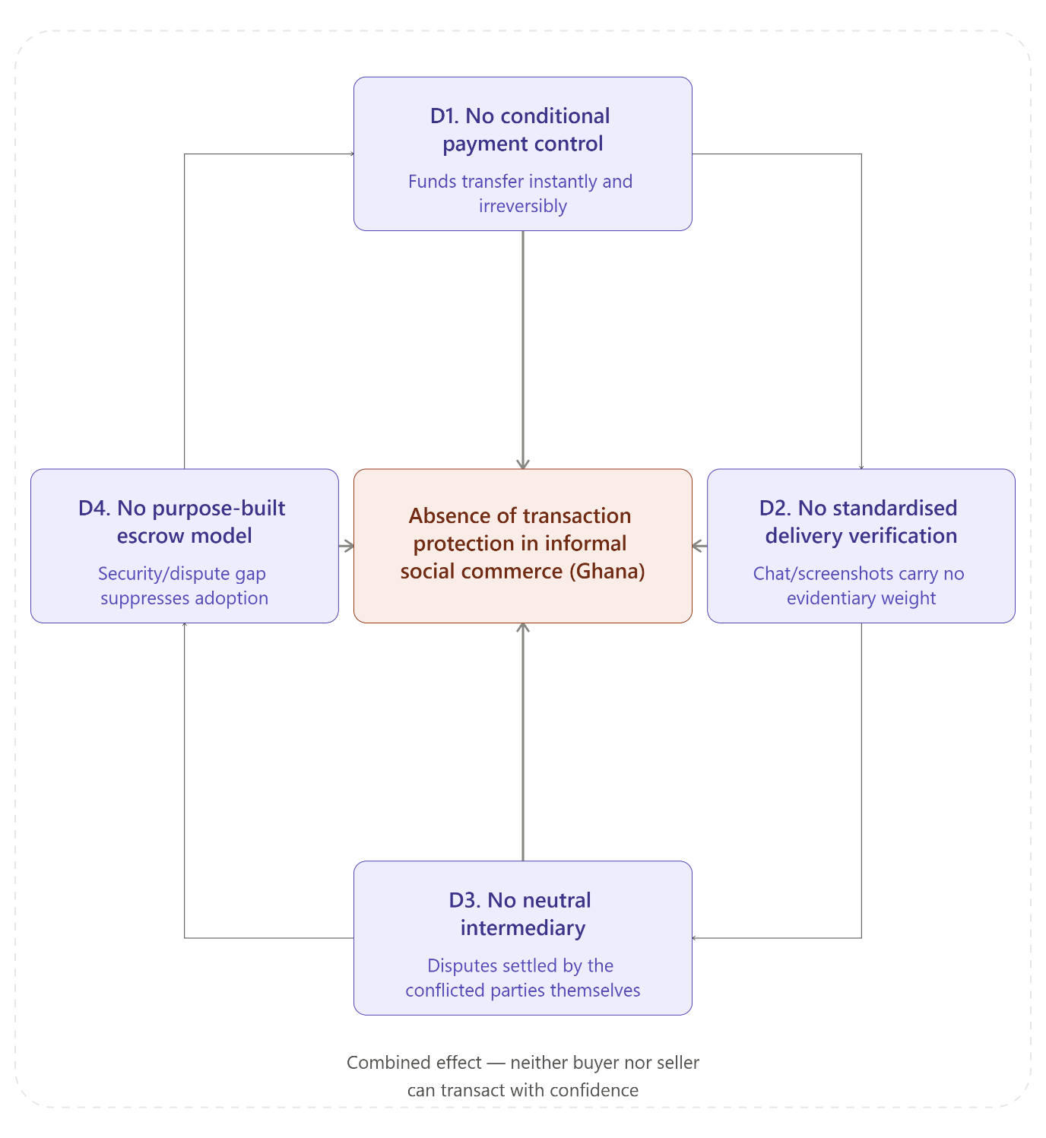
Figure 1.2: The Four Interconnected Deficiencies Producing the Trust and Payment Security Gap in Ghana's Informal Social Commerce

1.2 General Objective / Aim of the Study
The general aim of this study is to design and implement an escrow-based transaction model that provides structural payment protection for both buyers and sellers engaged in informal social commerce transactions in Ghana. The model addresses the trust and payment security deficit that currently characterises Ghana's informal social commerce environment by introducing conditional payment control, standardised delivery verification, and structured dispute resolution into a simple, shareable transaction interface accessible to informal sellers and buyers without requiring specialist technical knowledge or migration to a formal e-commerce platform.

1.3 Specific Objectives
The general aim of this study is pursued through the following four specific objectives:
- To identify and analyse the specific trust challenges and payment risks that buyers and sellers face in informal social commerce transactions in Ghana.
- To design an escrow-based transaction model suited to the operational context of informal sellers and buyers transacting through social media and messaging platforms in Ghana.
- To implement a conditional payment release mechanism that holds buyer funds securely until delivery is confirmed and manages disputes through a structured administrative process.
- To evaluate the perceived effectiveness and practical usability of the proposed escrow-based transaction model among informal social commerce participants in Ghana.

1.4 Research Questions
The study is guided by the following research questions, each corresponding directly to a specific objective and together forming the investigative spine of the research:
- What specific trust challenges and payment risks characterise informal social commerce transactions in Ghana, and how do they constrain participation and confidence among buyers and sellers?
- How can an escrow-based transaction model be systematically designed to address the identified structural trust deficits in informal social commerce in Ghana?
- How does a conditional fund release mechanism based on delivery confirmation reduce bilateral transaction risks for buyers and sellers in informal social commerce?
- To what extent is the proposed escrow-based transaction model perceived as effective and practically usable by informal social commerce participants in Ghana?

1.5 Research Assumptions
Academic research rests on foundational assumptions that define the conditions under which the study is valid and its findings are interpretable. The following assumptions are stated explicitly because they shape key decisions in the research design and establish the boundaries within which conclusions apply.

The first assumption is that informal social commerce sellers and buyers in Ghana possess the basic digital prerequisites necessary to participate in a web-based escrow transaction system, specifically access to a smartphone and a mobile money account. This is grounded in official data. The Bank of Ghana's Payment Systems Oversight Annual Report recorded 65.6 million electronic money accounts by end of 2023, with 22.8 million consistently active monthly (Bank of Ghana, 2024). (Osabutey & Jackson, 2024) further noted that mobile money has become a central driver of financial inclusion across Sub-Saharan Africa, with penetration sufficient to support digital financial services among the urban and peri-urban informal seller population that constitutes the primary target group of this study. While universal access cannot be assumed, the evidence confirms sufficient penetration to make the study viable.

The second assumption is that trust is both a measurable construct and one that responds meaningfully to structural intervention through system design. The study proceeds on the understanding that introducing a credible and functional escrow mechanism will produce a perceptible improvement in transactional confidence among buyers and sellers. (Mayayise, 2023) confirmed through a systematic review of 44 consumer-to-consumer e-commerce studies that structural assurances are among the most powerful drivers of trust in digital trade, with particularly strong effects in emerging market contexts where formal legal enforcement is limited.

The third assumption is that Ghana's existing digital payment infrastructure is technically capable of supporting conditional fund management within a self-contained system architecture. The Carnegie Endowment for International Peace (2022) confirmed that Ghana's regulatory environment explicitly supports licensed payment intermediaries operating within the digital financial system, and that mobile money interoperability between operators is sufficiently mature to accommodate conditional transaction logic.

The fourth assumption is that the purposively selected participants in the evaluation phase of this study are sufficiently representative of the broader informal social commerce population in Ghana to yield meaningful insights into the perceived usability and effectiveness of the proposed system, notwithstanding the absence of random national sampling.

1.6 Research Philosophy / Paradigm
Every research study is built on philosophical foundations, whether the researcher makes them explicit or not. These foundations determine what the researcher believes constitutes reality, how knowledge about that reality can be legitimately created, and what forms of evidence count as valid. Making these foundations explicit is not an academic formality. It is evidence that the researcher has carefully considered the alignment between their worldview, the nature of their research question, and the methods chosen to answer it.

This study is grounded in the pragmatist paradigm. Pragmatism holds that the value of any research approach lies in its capacity to generate practical, actionable knowledge. It does not privilege one philosophical tradition over another, nor insist that either qualitative or quantitative evidence is inherently superior. What matters is whether the chosen approach adequately answers the research question at hand. This study asks both what the problem is, which benefits from qualitative investigation of lived transactional experiences, and whether the designed solution works, which benefits from evaluative testing and measurable user feedback. Pragmatism accommodates both inquiry types within a single coherent research design.

Ontologically, this study adopts a realist position. The trust deficit in Ghana's informal social commerce ecosystem is treated as a real, observable, and empirically documentable phenomenon that exists independently of the researcher's perspective. Fraud incidents are recorded. Money is lost. Buyers are deceived. These are confirmed facts, documented in the Bank of Ghana's own fraud reports and in the academic literature cited throughout this chapter.

Epistemologically, the study adopts a constructivist position. While the problem is real and observable, knowledge about how best to solve it is constructed through the process of designing, building, testing, and refining the escrow transaction model, and through engagement with the subjective experiences of the people who use it. Two sellers may experience the same interface differently. Two buyers may have different trust thresholds. These variations are meaningful and must be engaged with interpretively, not merely measured.

This philosophical orientation aligns naturally with Design Science Research (DSR) as the study's primary methodological approach. DSR is the established research paradigm in Information Systems for studies whose primary output is a constructed artifact rather than a tested hypothesis. As (vom Brocke et al., 2020) established in the Journal of the Association for Information Systems, DSR proceeds by accumulating and evolving design knowledge: each project consumes existing knowledge and produces new prescriptive knowledge for future work. Its iterative process, moving from problem identification through design and development to demonstration, evaluation, and communication, provides the structured methodology through which the escrow transaction model is built and assessed. Crucially, DSR demands both rigour and relevance: the artifact must be technically sound, and it must demonstrably solve a real-world problem.

The evaluation phase additionally draws on an interpretivist lens, recognising that the perceived usability and trustworthiness of the system cannot be assessed through technical performance metrics alone. The experiences and perceptions of the informal sellers and buyers who test the system are treated as legitimate evidence, captured through structured questionnaires and qualitative feedback sessions, and analysed using mixed-method techniques consistent with the study's pragmatist philosophical orientation.

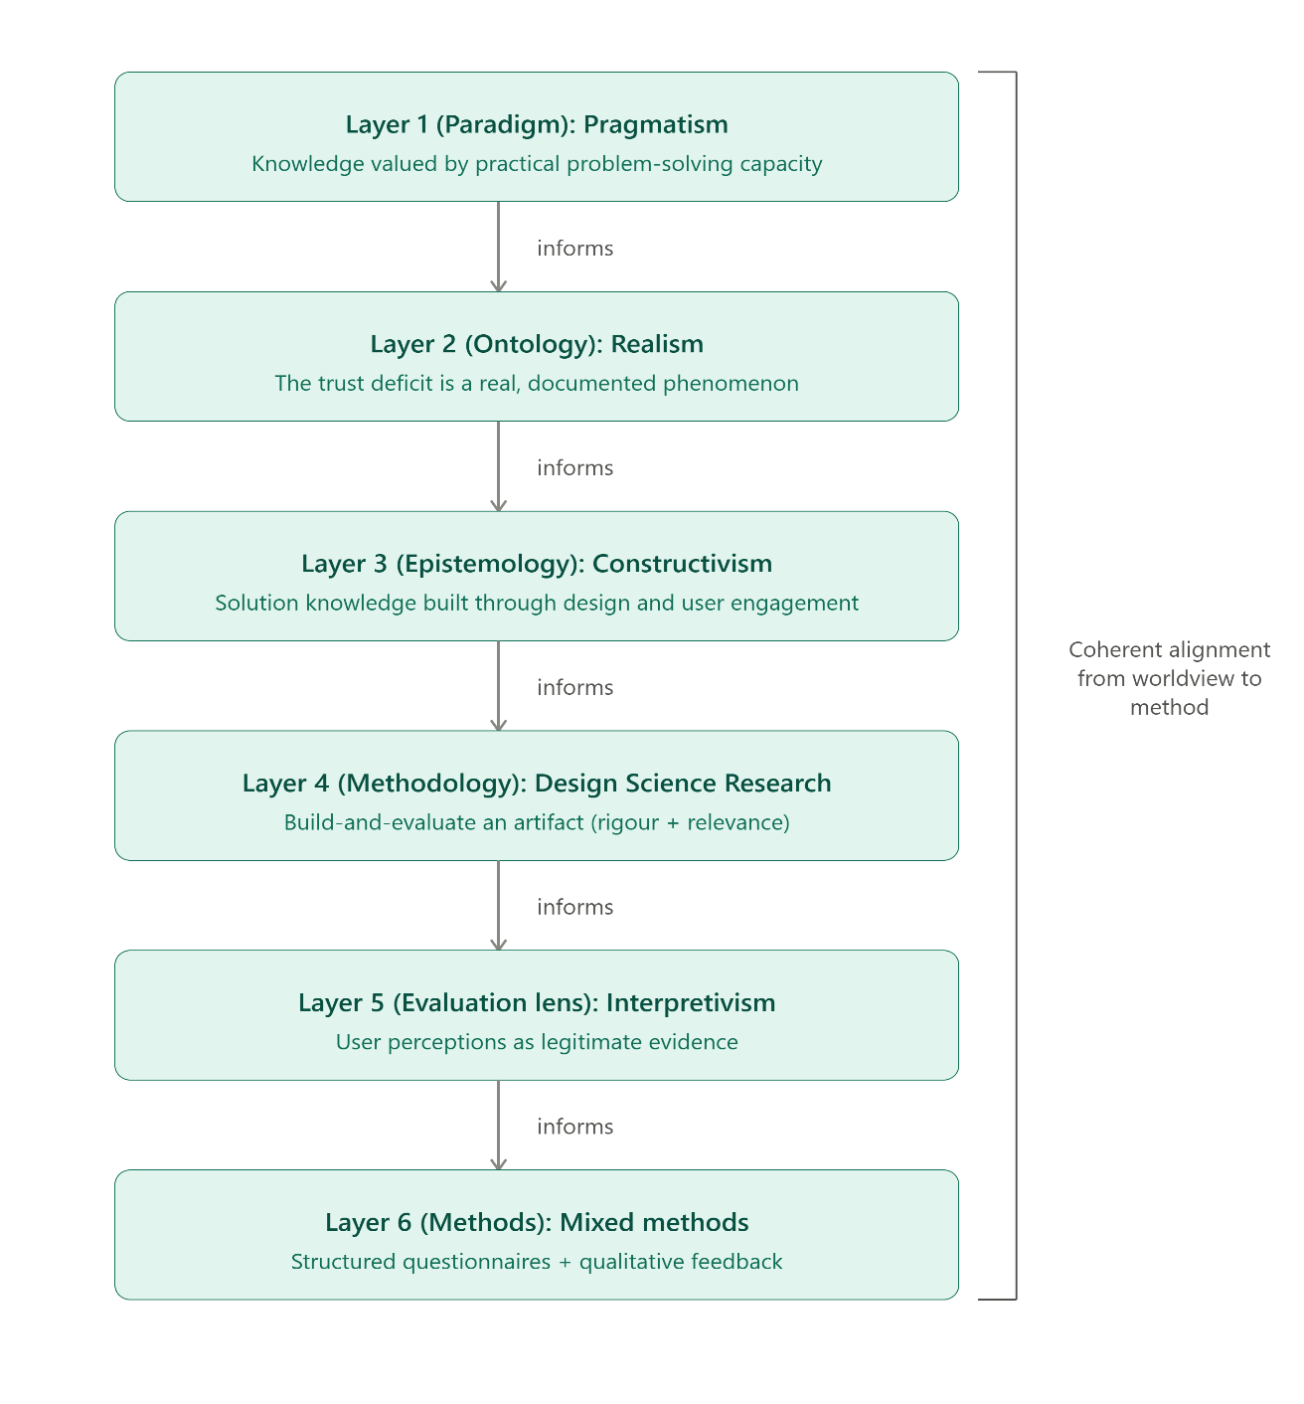

Figure 1.3: Alignment of Research Paradigm, Ontology, Epistemology, Methodology, and Methods in the Study

1.7 Justification / Significance of the Study
The significance of this study operates at three intersecting levels, each reflecting a different dimension of the problem being addressed and the contribution the study makes toward resolving it.

From an academic perspective, this study addresses a gap in the Information Systems literature that has remained largely unexplored. While trust mechanisms in formal e-commerce platforms have been extensively studied across multiple contexts, the application of institution-based trust theory to informal, conversational commerce environments in Sub-Saharan Africa has received comparatively limited attention. By designing and evaluating an escrow-based transaction model in this specific context, the study extends the application of Trust Theory, Institution-Based Trust, and the Technology Acceptance Model into new empirical territory. It also contributes to the Design Science Research body of knowledge by demonstrating how DSR can address commerce protection problems in developing economies, where the gap between available technology and practical user protection is most acute. As (Leong et al., 2024) identified in their mapping of the social commerce research landscape, trust in informal and cross-platform social commerce contexts in developing markets represents one of the most significant underexplored areas in the field.

From a practical perspective, the study produces a working system that informal social commerce participants in Ghana can use without migrating from their preferred social platforms, without acquiring technical expertise, and without the cost of formal marketplace registration. A seller completes a negotiation through their preferred messaging application, generates a secure transaction link through the escrow system, shares it in the conversation, and both parties are automatically protected throughout the transaction lifecycle. The model is designed to be reusable and platform-agnostic. (Achieng & Malatji, 2022) specifically noted that the most impactful digital commerce interventions for SMEs in Sub-Saharan Africa are those that fit within existing workflows rather than requiring workflow transformation, which is precisely the design principle guiding this study.

From a policy perspective, the study aligns directly with Ghana's digital economy agenda and the financial inclusion objectives of the Bank of Ghana's regulatory framework. (Carnegie Endowment for International, 2022) documented that while Ghana's regulatory environment is broadly supportive of digital financial intermediaries, consumer protection mechanisms for informal digital trade remain underdeveloped. (Carnegie Endowment for International, 2024) further noted that Africa loses approximately $4 billion annually to cybercrime, resulting in a measurable reduction in GDP across the continent. By providing informal traders with a system that structurally prevents the most common forms of payment fraud in social commerce, this study contributes to building the trust infrastructure Ghana's digital economy requires.

1.8 Scope of the Study
The boundaries of this study are defined along four dimensions: geography, platform, user population, and technical implementation. Clarity on these boundaries ensures the findings are interpreted correctly and the system is evaluated against the problem it was designed to solve.

Geographically, the study is situated entirely within Ghana. While the informal social commerce problem addressed is recognisable across West Africa and much of Sub-Saharan Africa, the transaction model is designed, implemented, and evaluated in the Ghanaian context. The findings may inform similar initiatives in other markets with comparable mobile money infrastructure and informal commerce cultures, but no cross-national generalisations are claimed.

In terms of platform scope, the study targets informal commercial transactions initiated and negotiated through social media and messaging platforms such as WhatsApp, Facebook, Instagram, TikTok, Telegram, and other similar tools commonly used for commerce in Ghana. The transaction model is platform-agnostic by design: it operates through a shareable checkout link that functions across all these platforms without requiring integration with any of them. This architectural decision ensures the model remains relevant as the social commerce platform landscape continues to evolve, a dynamic that (Leong et al., 2024) identified as one of the defining challenges for researchers and practitioners in this field.

In terms of user scope, the study focuses on micro-entrepreneurs and independent informal sellers who do not operate registered e-commerce stores and conduct their commercial activity entirely through personal social media accounts and messaging applications, along with the buyers who transact with them. Large registered businesses, formal retailers, and enterprise-level commercial operations are outside the scope of this study.

In terms of technical scope, the system is built as a web-based application accessible through a shareable transaction link. Payment funds are managed and held internally within the system, with conditional release triggered by a confirmed delivery event. The study does not incorporate blockchain-based or cryptocurrency escrow mechanisms. Licensed payment gateways operating in the Ghanaian market are referenced in the literature review as evidence of existing infrastructure and regulatory precedent, but they are not architectural dependencies of the system developed in this study.

1.9 Limitations of the Study
Acknowledging the limitations of a study is not a concession of weakness. It is an act of scholarly integrity that enables readers to correctly interpret the findings and understand the conditions under which the conclusions are valid. The following limitations have been identified and, where possible, mitigated through careful research design.

The first limitation concerns sample size and representativeness. The evaluation phase employs a purposive sample of informal social commerce sellers and buyers in Ghana. While purposive sampling is methodologically appropriate for a DSR evaluation focused on system usability and perceived effectiveness, it does not support broad statistical generalisation to Ghana's entire informal social commerce population. Findings reflect the experiences of the selected participants and should be interpreted within that bounded context. Larger-scale validation studies using random sampling would be required to support population-level claims.

The second limitation relates to the self-contained payment architecture. Because payment funds are managed internally within the system rather than through a licensed third-party payment gateway, there are practical constraints on the real-money transaction volumes that can be safely processed during evaluation and testing. The system is assessed primarily on functional logic, interface usability, and the trust perceptions it generates, rather than on high-volume financial throughput. Full commercial deployment would require integration with a licensed payment service provider and compliance with relevant Bank of Ghana directives governing payment intermediaries.

The third limitation is the observer effect. Participants in the evaluation phase are aware that they are being studied as part of a formal research exercise. This may cause them to engage with the system more carefully or report more positive experiences than in a fully natural, unsupervised commercial transaction. This well-documented challenge in usability research, sometimes called the Hawthorne effect, means evaluation findings should be understood as reflecting contextually supported usage behaviour rather than the full range of naturalistic user conduct.

The fourth limitation concerns regulatory evolution. Ghana's digital payment and cybersecurity regulatory landscape is evolving rapidly. The Bank of Ghana has issued new directives and new fraud reporting requirements within the period covered by this study (Bank of, 2023). Some regulatory details cited may be superseded by subsequent policy developments. The system design reflects the regulatory requirements current at the time of development, and ongoing compliance review would be necessary before any large-scale commercial deployment.

The fifth limitation is the absence of longitudinal data. This study captures a snapshot of user perceptions and system performance at a specific point in time, during and immediately following implementation. It does not track long-term adoption rates, behavioural changes across repeated transactions, or the sustained evolution of trust perceptions over time. A longitudinal follow-up study would be required to determine whether the positive effects observed during evaluation persist or attenuate over extended use.

1.10 Organisation of the Study
This thesis is structured into five chapters, each serving a specific and deliberate purpose in the progression from problem identification through solution design and implementation to evaluation and conclusion. Together they form a coherent research narrative that moves from establishing the problem to demonstrating its resolution.

Chapter One is this introductory chapter. It has established the background context of social commerce in Ghana, articulated the structural problem of trust and payment security deficit in informal digital trade, stated the general aim and specific objectives, formulated the guiding research questions, declared the foundational assumptions and research philosophy, justified the significance of the study, defined the scope, and acknowledged the limitations.

Chapter Two presents the Literature Review, organised per study objective in accordance with the prescribed research structure. For each objective, the relevant theoretical and empirical literature is reviewed and critically engaged. The chapter covers social commerce in Africa and Ghana, trust in digital transactions, payment risk and digital fraud in the Ghanaian context, escrow mechanisms and their documented effectiveness, mobile money as the transactional infrastructure of informal social commerce, the Technology Acceptance Model as the evaluative framework, and Design Science Research as the methodological paradigm. It concludes with the identification of the specific research gap and the conceptual model guiding the study.

Chapter Three details the Research Methodology. It explains the research design, the population and sampling strategy, the data collection methods, and the system design and development process. This chapter presents the architectural design of the system, the escrow transaction model diagrams, entity relationship diagrams, use case diagrams, and data flow designs that constitute the planned system blueprint. It also addresses data analysis techniques, validity and reliability measures, and the ethical considerations governing the study.

Chapter Four presents the Data, Analysis, and Discussion. It profiles the research participants, presents the system evaluation results, and provides detailed analysis and interpretation of findings in relation to each research question. This chapter also presents the implemented system in full, including screenshots of the working application, documentation of system testing and its outcomes, and a critical discussion of findings in the context of the literature reviewed in Chapter Two.

Chapter Five provides the Summary, Conclusions, and Recommendations. It synthesises the key findings, draws conclusions in direct relation to each research question and objective, makes targeted practical recommendations for informal sellers, system developers, and policymakers, and proposes specific directions for future research that this study has opened but not fully explored.

References
Abdulai, M. G., Dary, S. K., & Domanban, P. B. (2024). Adoption of digital payment platforms and trade credit activities among informal firms in Ghana. Heliyon, 10(11).
Achieng, M. S., & Malatji, M. (2022). Digital transformation of small and medium enterprises in sub-Saharan Africa: A scoping review. The Journal for Transdisciplinary Research in Southern Africa, 18(1), 1257.
Ali, A. (2022). Decentralised escrow protocol that facilitates secure transactions between trustless parties. Proceedings of the International Conference on Innovative Computing & Communication (ICICC),
Arhin, S. (2023). Indicators of financial fraud in the Ghanaian mobile payment industry in the pre-pandemic period. Global Journal of Business, Economics and Management: Current Issues, 13(1), 36-51.
Bank of, G. (2023). Banks, SDIs and PSPs fraud report 2023. https://www.bog.gov.gh/news/banks-sdis-psps-2023-fraud-report/
Bank of, G. (2024). Payment systems oversight annual report 2023. https://www.bog.gov.gh/wp-content/uploads/2024/09/Payment-Systems-Oversight-Annual-Report-2023.pdf
Carnegie Endowment for International, P. (2022). Digital financial inclusion and security: The regulation of mobile money in Ghana. https://carnegieendowment.org/research/2022/09/digital-financial-inclusion-and-security-the-regulation-of-mobile-money-in-ghana
Carnegie Endowment for International, P. (2024). Security and trust in Africa's digital financial inclusion landscape. https://carnegieendowment.org/2024/03/08/security-and-trust-in-africa-s-digital-financial-inclusion-landscape-pub-91932
Gsma. (2023). The state of the industry report on mobile money 2023. https://www.gsma.com/sotir/
Jain, V., & Jain, N. (2024). From cash to clicks: A systematic review of digital payment adoption using the ADO framework. NMIMS Management Review, 32(4), 277-291. https://doi.org/10.1177/09711023241312523
Leong, L.-Y., Hew, T. S., Ooi, K.-B., Hajli, N., & Tan, G. W.-H. (2024). Revisiting the social commerce paradigm: The social commerce (SC) framework and a research agenda. Internet Research, 34(4), 1346-1393.
Mayayise, T. O. (2023). Investigating factors influencing trust in C2C e-commerce environments: A systematic literature review. Data and Information Management, 7(3), 100037. https://doi.org/10.1016/j.dim.2023.100037
Osabutey, E. L., & Jackson, T. (2024). Mobile money and financial inclusion in Africa: Emerging themes, challenges and policy implications. Technological Forecasting and Social Change, 202, 123339.
vom Brocke, J., Winter, R., Hevner, A., & Maedche, A. (2020). Accumulation and evolution of design knowledge in design science research: A journey through time and space. Journal of the Association for Information Systems, 21(3), 520-544. https://doi.org/10.17705/1jais.00611
Wang, J., Shahzad, F., Ahmad, Z., Abdullah, M., & Hassan, N. M. (2022). Trust and consumers’ purchase intention in a social commerce platform: A meta-analytic approach. Sage Open, 12(2), 21582440221091262.

